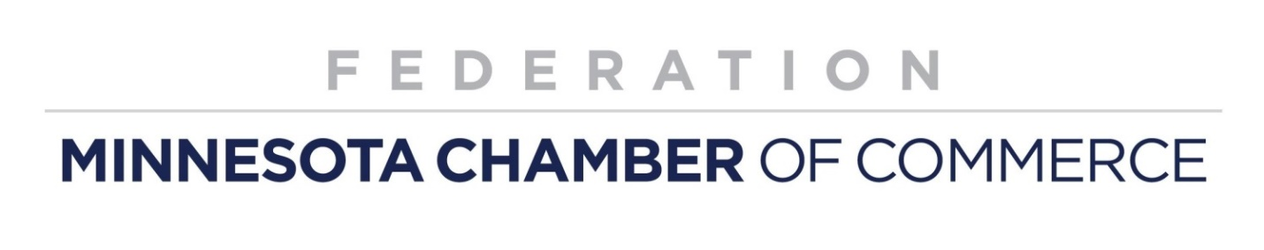

2021 Legislative Session Priorities
Minnesota’s economic recovery is imperative

Local chambers represent economic vitality in their communities. The Minnesota Chamber Federation unites and amplifies the voice of local chambers by advocating for policies to advance business in every corner of the state. Federation partners represent more than 43 communities and more than 21,000 businesses. The have worked to promote pro-growth policies to the Legislature for more than a decade, helping ensure that state lawmakers understand the needs and interests of Minnesota’s diverse and successful local business community.

Support employers and employees throughout the COVID-19 pandemic
The impact of COVID-19 on the statewide economy and many sectors of the business community will have lasting impact and the legislature must first “do no harm” and instead pass measures that spur recovery and economic growth. Businesses cannot sustain additional tax and fee increases, mandates, regulatory burdens and other measures that will further impede business recovery.

We support:
- Tax reforms and small business grants to provide hard-hit industries with immediate cash flow.
- Enacting COVID-19 lawsuit liability protections for businesses.
- Maintaining and enhancing connectivity, i.e. broadband.
- Reorienting workforce development programs based on immediate needs in a post-COVID-19 economy.
- Maximizing the ability of schools to bring students safely back to campus for in-person, full-time instruction.
- Providing one-time targeted child care funding to meet the needs of low-income and essential workers and providers.

Maintaining benefit flexibility
We are committed to providing the best workplaces for employees. As demonstrated throughout the pandemic, Minnesota employers adhere to strict safety protocols, labor laws and workplace standards to maintain healthy, respectful and inclusive workplaces. We support employer flexibility in determining workplace wage, benefit, scheduling and staffing decisions. Employers design benefit packages to meet their employees’ needs. Employer protections must be recognized, addressed and implemented if Minnesota legalizes use of recreational marijuana.

Ensuring high-quality, affordable health care
Health insurance is an increasingly important benefit, allowing employers attract and retain talent in the marketplace and ensure their employees stay healthy and productive at work. We oppose additional mandates and taxes that drive up costs and instead, urge the legislature to improve coverage options including continued stability in the individual market through reinsurance. We oppose a government-sponsored public option which would lead to significant financial impacts on providers and hospitals – especially in rural areas and underserved communities and increase costs for those with private coverage – whether fully-insured or self-funded – because health care providers will be forced to shift even more costs to these Minnesotans.

Transportation Investment
Current estimates indicate that the state’s transportation revenues will decline by roughly $400 million in the current biennium due to the reduction in travel and economic activity associated with the COVID-19 pandemic. We recognize that finding solutions to the near-term revenue shortfall will be difficult during a time of General Fund budget deficits, economic turbulence, and pandemic, however we must maintain, and if possible increase general fund revenues dedicated to transportation. Other funding options include increased fees for electric vehicles, increased tab fees (through a depreciation schedule adjustment) and achieving more investment through greater efficiencies.

Energy and the environment
Environmental sustainability and economic competitiveness, if done right, are not mutually exclusive.
We support achieving Minnesota businesses’ sustainability goals while keeping Minnesota energy rates competitive. We must continue needed progress on permitting efficiencies and streamlining.

